John Hunt Publishing - Cosmic Egg Books - announces the new title
I, Human  John Nelson  Where George Orwell in 1984 feared a totalitarian world of total camera surveillance, and Aldous Huxley in Brave New World foretold of the use of psychopharmaceuticals to placate the masses, I, Human posits that next techno advance toward this dystopia would be the use of neural implants and their drug conditioning. The downside is that they repress feelings and intuition causing emotional breakdowns that threaten the control of the techno oligarchy in the future. Made from human brain cells, the implants are subject to the same psychosomatic pressures. However, after fifty years of their use, the techno elites have lost the ability to program integrative functioning. Their control is further threatened by the Bornies, those who refuse the mental upgrades and have created their own flourishing low-tech society. This sets the stage for Alan Reynard and his journey from a callous transhuman operative to a feeling-oriented intuitive human being. He infiltrates a spiritual community to spy on its leader, healer Maria Fria, who has modified these implants for more functionality. The effects of his own healing transforms him and sets him on a course to undermine the oligarchy's social control.  Author Bio  John Nelson is a former editorial director, and now owner of Bookworks Ltd. He is the author of Starborn, Transformations, Matrix of the Gods and the award winning The Magic Mirror.  Online: Facebook, Author Website, Twitter  Previous Titles  The Magic Mirror (9781571745507) Red Wheel/Weiser, 2007-2012, 4,745. Starborn (0915442684), Donning Co., 11/78-1993, 10,144 copies. Hampton Roads 3/93-6/07 2406. Transformations (0898655498) Donning Co/Hampton Roads., 11/88-6/13, 1673 copies (over two editions). Matrix of the Gods (1878901974), Hampton Roads Pub, 9/94-6/2013, 2252 copies.  Endorsements  "In John Nelson's futuristic and aptly titled spy thriller, I,Human, he explores the boundaries of what it means to be human . . .Intelligence analyst Alan Reynard is sent on a mission to secretly infiltrate a Bornie spiritual community whose leader, Maria Fria, seems to be able to heal people and enhance emotion in ways beyond what the brain processors can do. But those who have sent him have not revealed the real purpose of his mission and Reynard and an outcast former operative, Emma, will find themselves on a dangerous exploration into the truth of self, consciousness and who we are and can be. An intriguing and superb futuristic spy thriller."  -Andrew Kaplan, author of the Scorpion and Homeland novels.  "John Nelson, in I, Human, imaginatively gives an apocalyptic scenario about the dark sides of pharmacogenomics and neural implants. He tackles a ticklish question. What exactly is a human being, and is there an invisible line inside that splits the human biocomputer into part man and part machine? And how will governments of the future manipulate it?"  -Henry David Abraham, M.D., author, co-recipient of the 1985 Nobel Peace Prize  USP  Poses the question: will the future use of neural implants erode our feelings and intuitions and turn us robotic?  Competing Books  Nexus (978085766934), by Ramez Haam  Angry Robot, 2012  Categories  FICTION(FIC028020) -> Science Fiction(FIC028020) -> High Tech(FIC028020)  FICTION(FIC028010) -> Science Fiction(FIC028010) -> Adventure(FIC028010)  FICTION(FIC055000) -> Dystopian(FIC055000) |  | 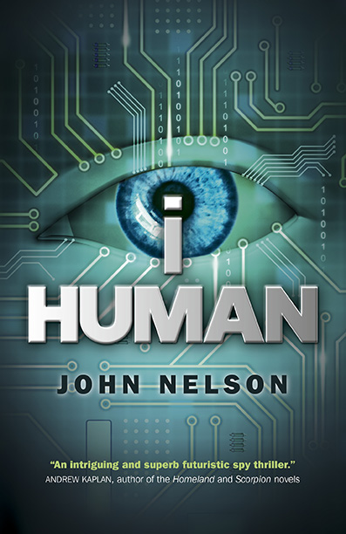  Publication Date  May 27, 2016  Paperback  ISBN: 978-1-78535-330-7  $18.95 | £10.99  8.5x5.5 inches | 216x140 mm  288PP  e-book  ISBN: 978-1-78535-331-4  $7.99 | £4.99  Library of Congress  2015953282
Distributed to the trade by National Book Network in US; by Orca Marston in UK
Publisher contact: catherine@jhpbooks.net
cosmicegg-books.com

